CitationDB Application

Lead Designer/Developer

Domingo Vargas Anchondo

2019

**Purpose**

Education is an important part in creating opportunities for people to make an impact in this world and therefore we have come up with many tools that allow us to focus on the knowledge at hand emphasizing the amount of time we could save on the most miniscule tasks. The reason for the creation of this application is to allow students to keep track of their research papers and the citations that they have curated through their research. This allows students to avoid plagiarizing their research by allowing them to be generated and stored in a database for future reference or in the case of an unforeseen circumstance. There are many websites that contain citation generators however, many of them do not store the citations therefore students may have trouble locating their research citations in the case of an emergency. The application would consist of an account-based dashboard that would allow a student to use many of the features that would be implemented at launch and many more that may be added or improved throughout the years. The main functionality of the application would allow users to create a project and then input the information of the research article. Website, or any other medium and have the citation generated for them. Each citation would be saved according to the project that the user saved them under and therefore allowing the user to come back to the citation if they may need to in the future.

**The Project Plan and Platform**

For this project I will be creating a citation editor that will allow users to create an account and use the tools to create APA citations. I chose APA because it is what we use at Rasmussen and having other citation formats while good and beneficial for most will result in making the project longer to create. Therefore, other formats will only be considered if there is enough time to implement them. The platform I will use is Universal Windows Application pairing it with Azure APP services and MicrosoftSQLite. The project will be completed as follows:

1. Decide application features
2. Design Application layout and logo
3. Create Login screen to Register and Login Users and implement Azure services
4. Create Page to Form citations
5. Create Page to see citations
6. Create About Us Page
7. Clean Up Project

The application upon launch will show the login screen first prompting the user to either login or register. If the user needs to register the user will click the register button and the application will navigate to the registration page. Once the user is registered, they will login and be able to access the application. The main page of the application will have the form to input information so that the citation could be generated. Once the citation is generated the user can access the page that will contain all the citations that the user generated. The third page will be an about us page and future of the project.

**Create Home Screen and Database**

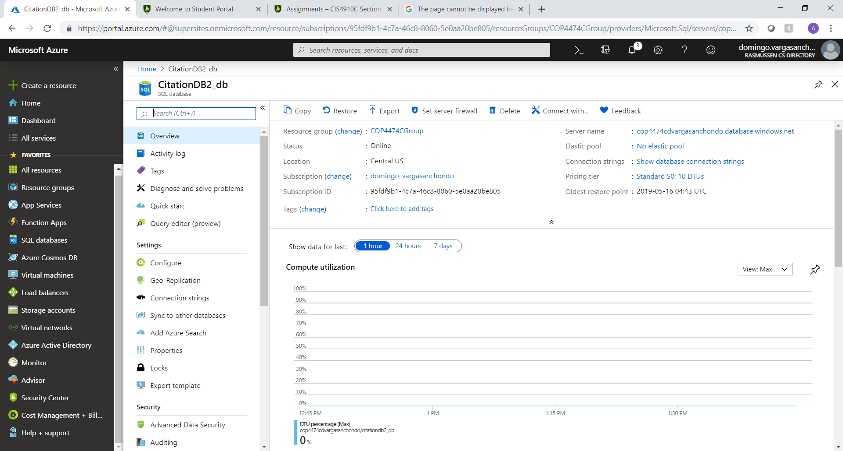The Database that I created was a SQL database on Microsoft Azure.

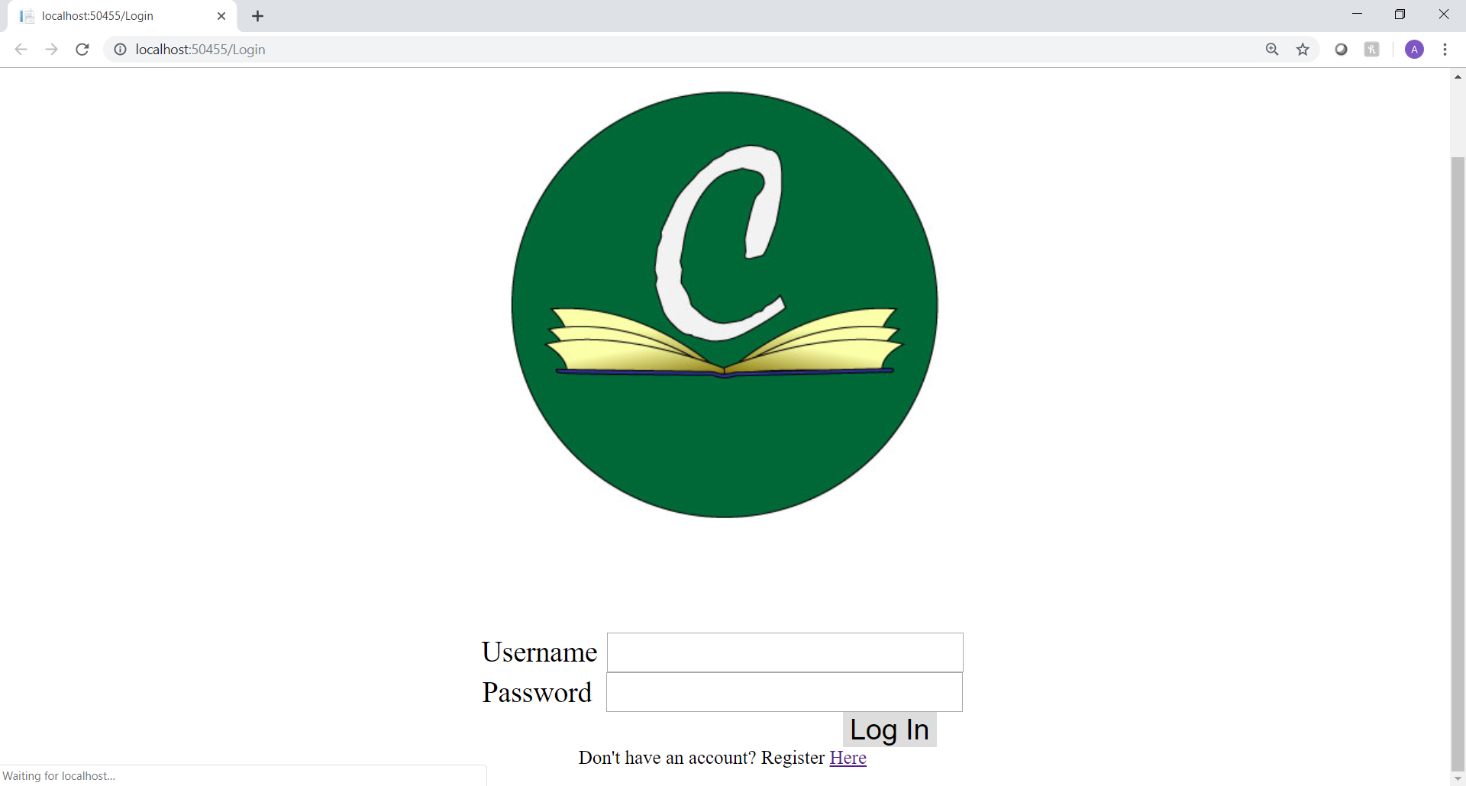

The main screen when the application is accessed is the Login Screen which checks if a user’s credentials are in the database or not.

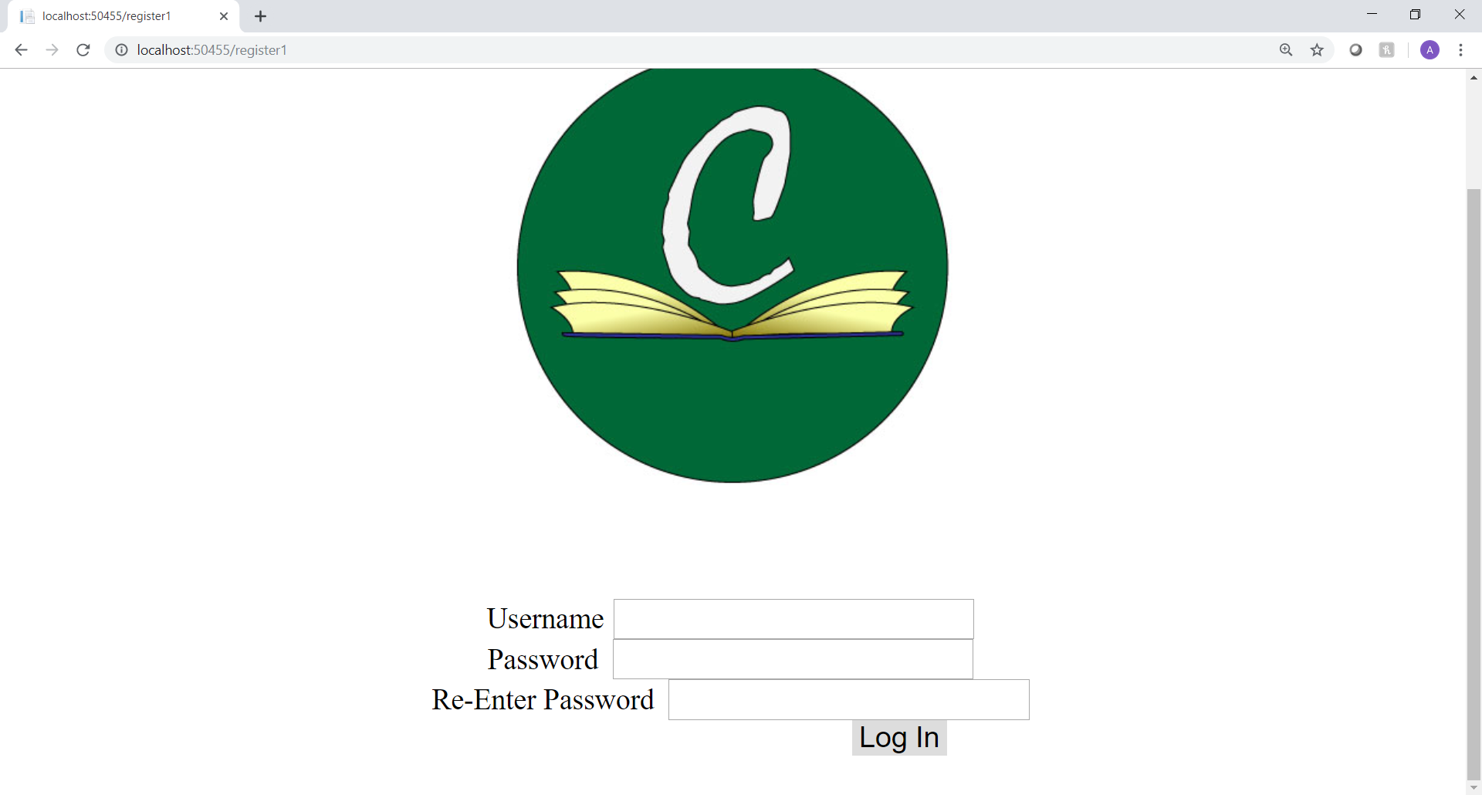

There is also a register screen that will let a user create their own account.

**Test Code and Database Functions**

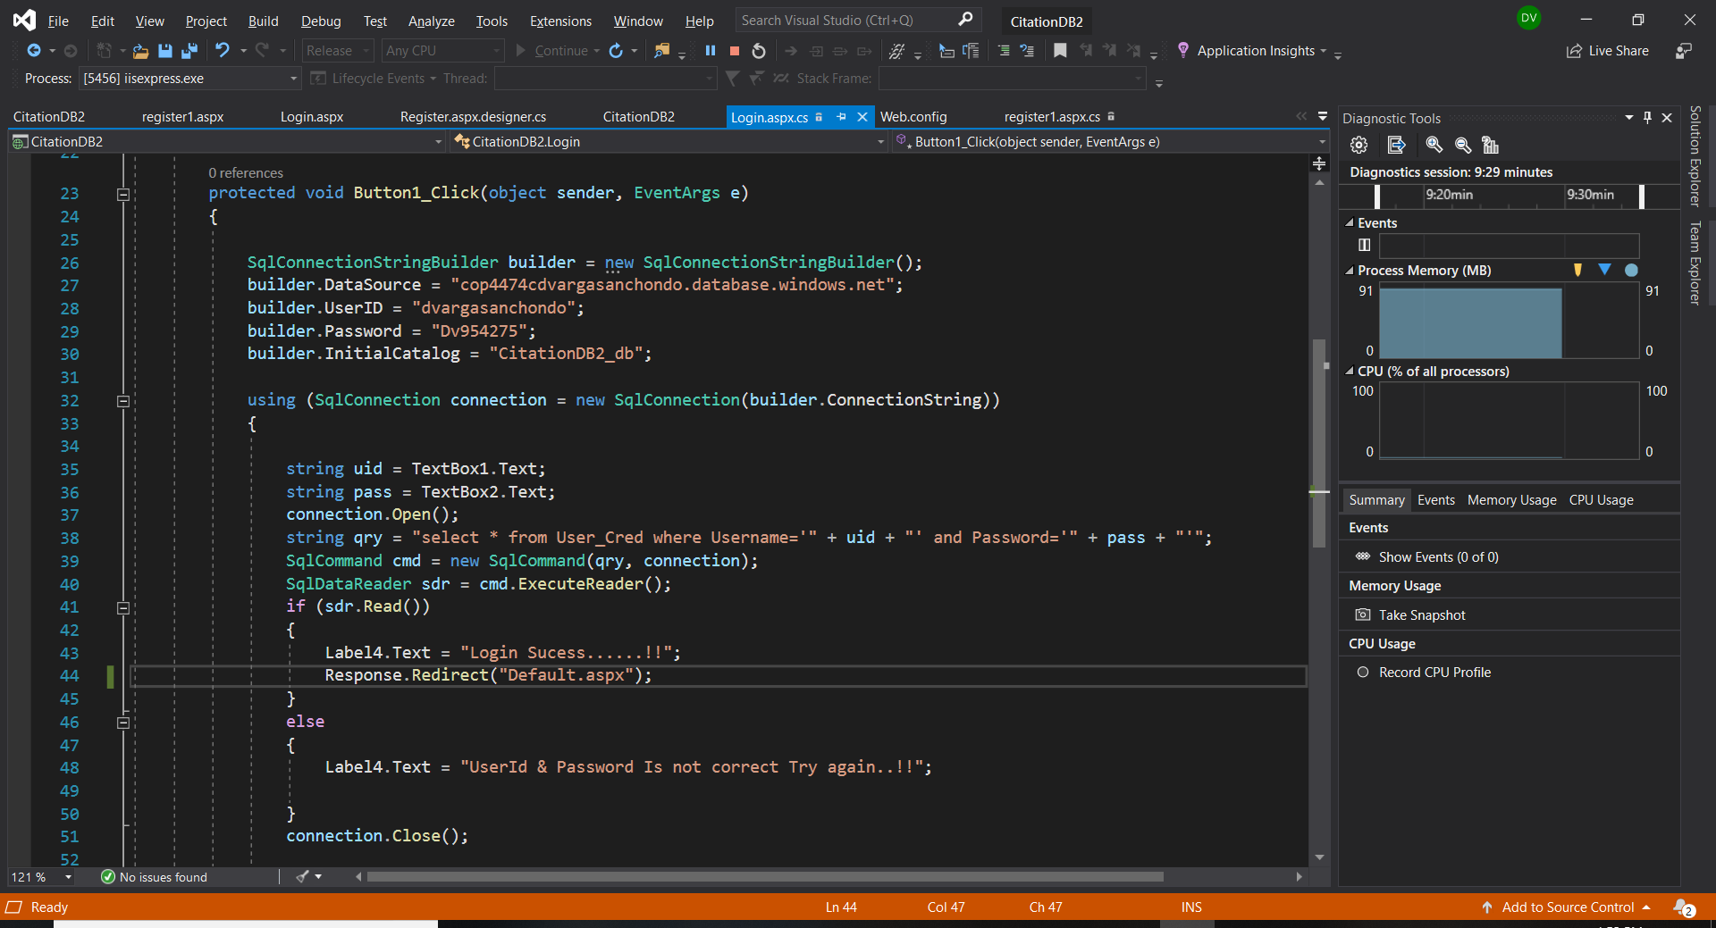

Code for logging in and checking the user accounts for the user’s credentials.

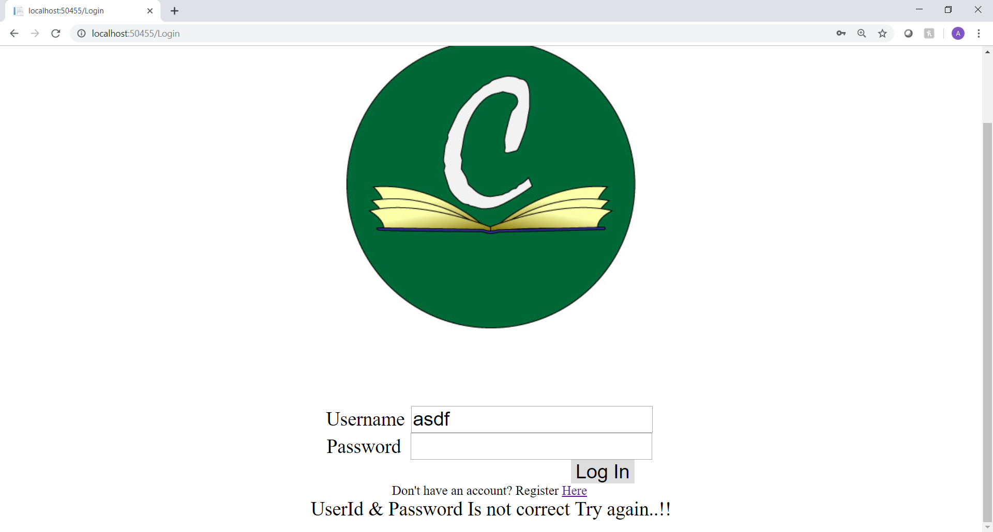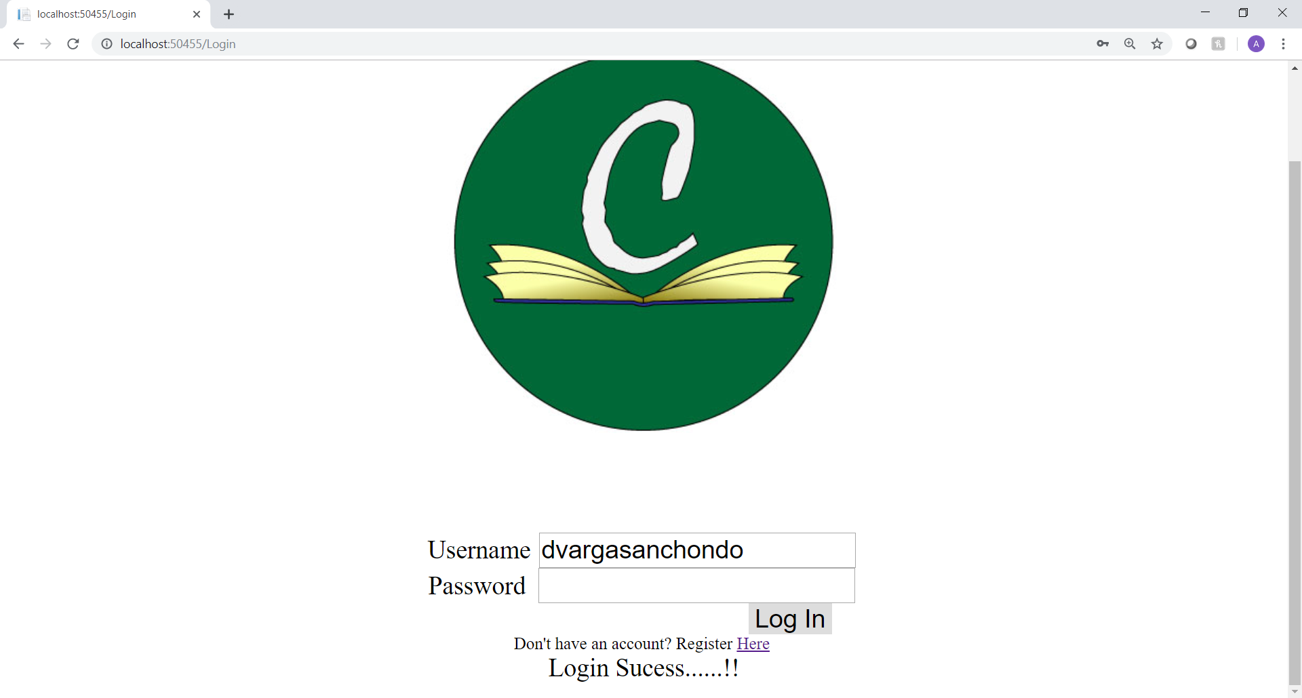

Both screen shots show the way that the code works. I’ve omitted the redirect on login success in order to show that the application is working as intended and because the main user screen is still being designed and worked on.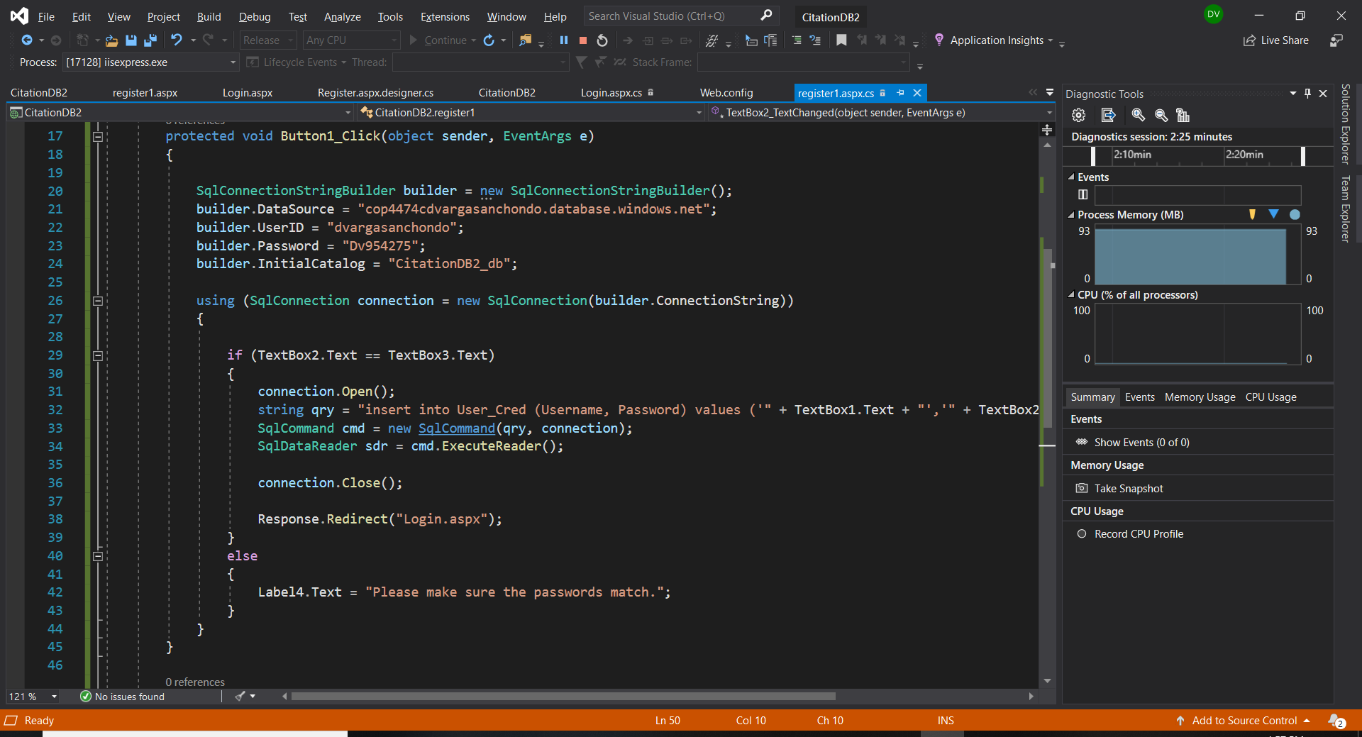The code for the register shows that there is an if that checks if both password boxes have the same password and if they do then it will send that information to the database. If not it’ll display the error message. 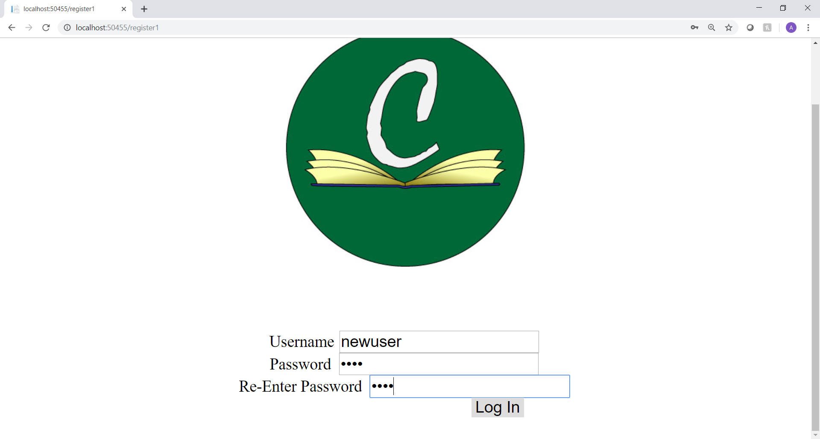

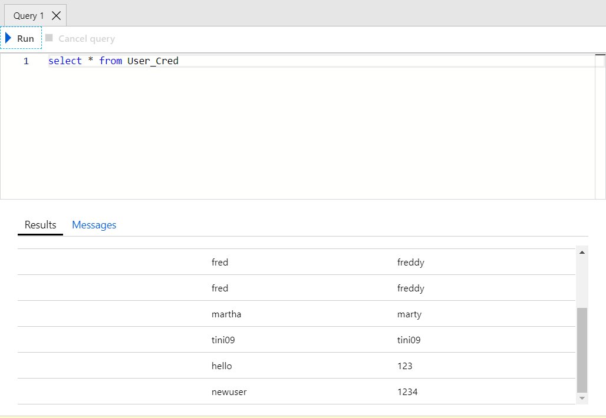

Both screenshots show the register screen in action. Once the user registers, they will be automatically redirected to the login screen. If not, the error message will display. The query on the bottom is on the azure side where I use to check if the data is being received. The duplicate credentials on the top are when I was trying to make the connection and query work and used the same credentials to register without realizing it worked the first time.

**Create Code for Screens 1 and 2**

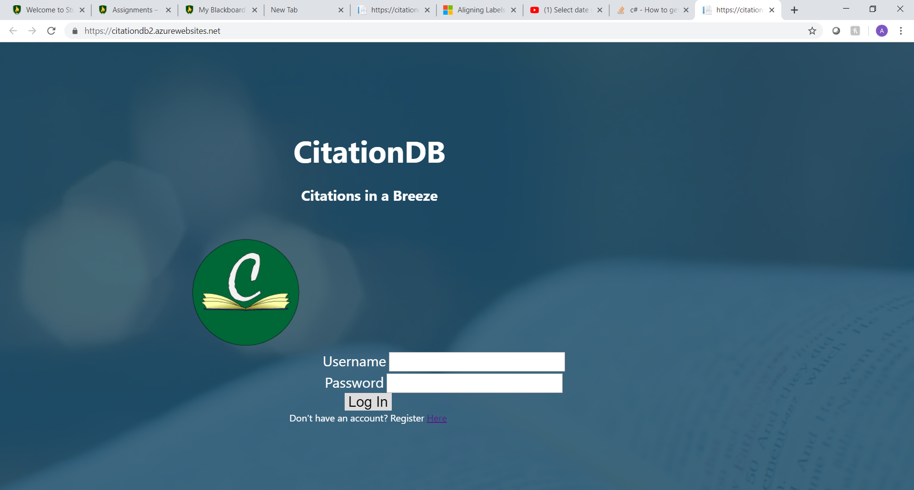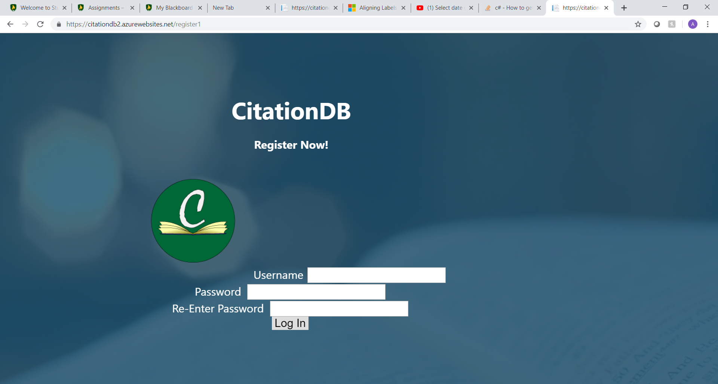

The Login and Register screens have been redesigned including an animated background of a book flipping pages. The stock video was stock and free to use for any purpose as I downloaded it from a stock video website. There are some issues that I want to still tackle like alignment of the text boxes, but this is okay for now.

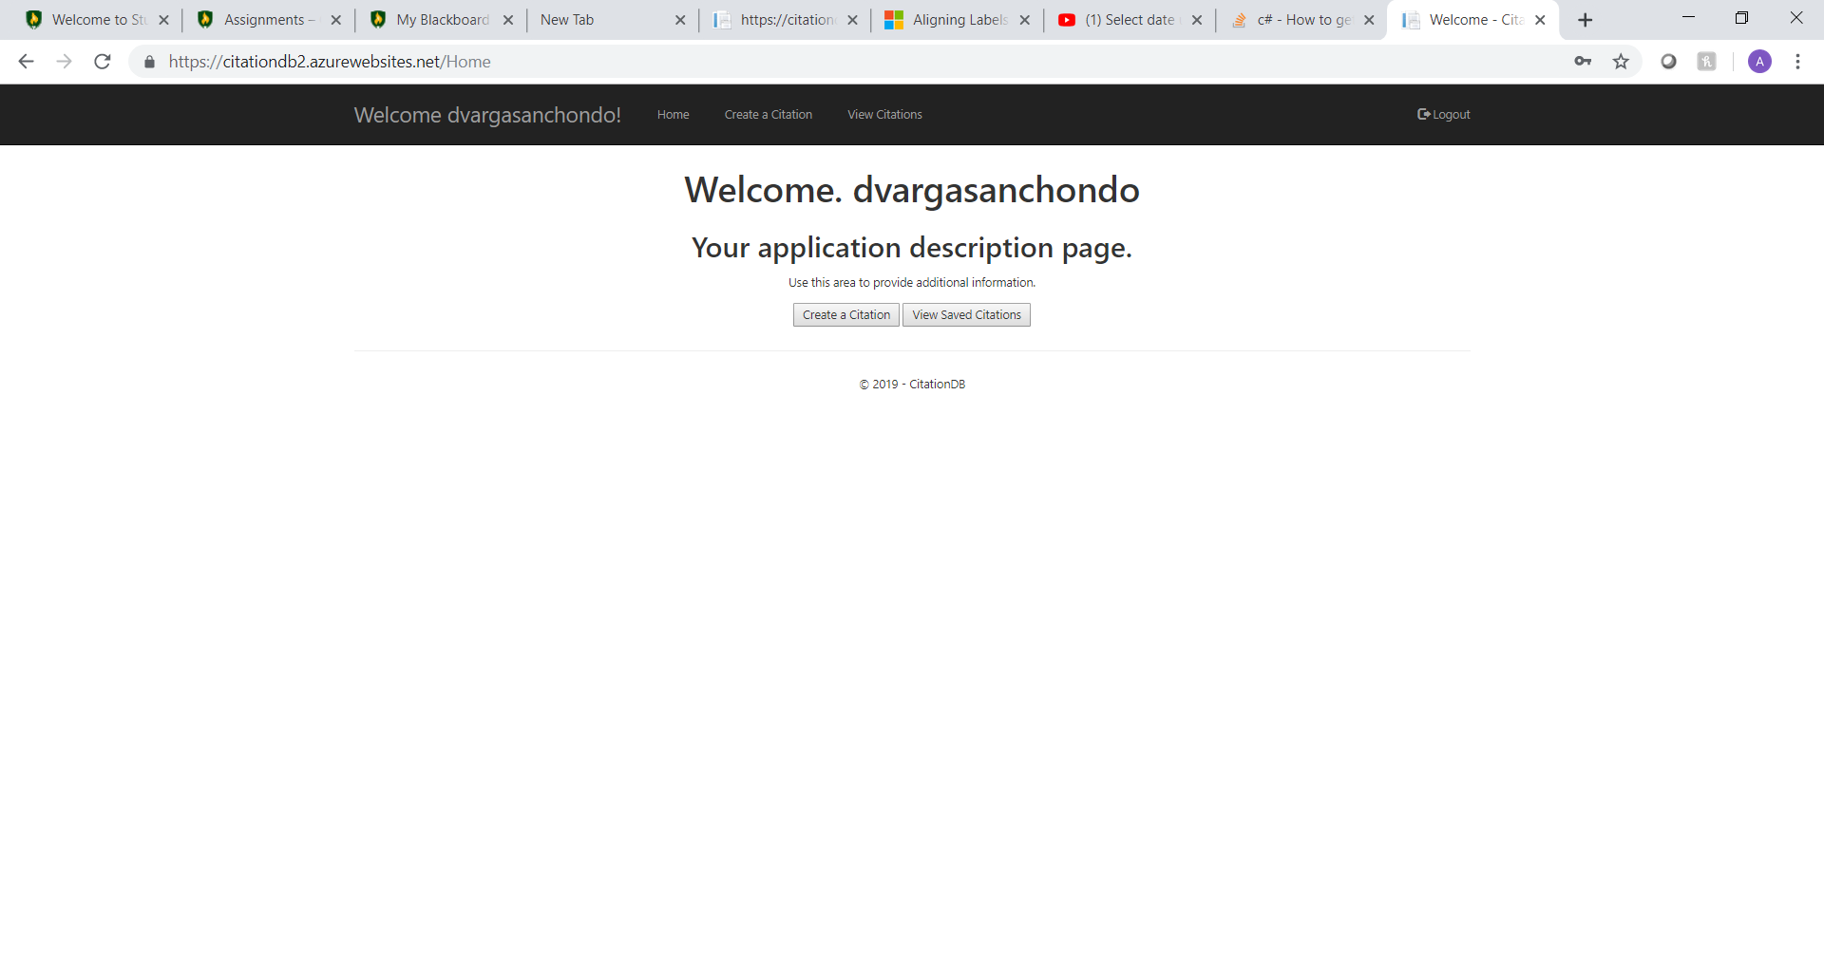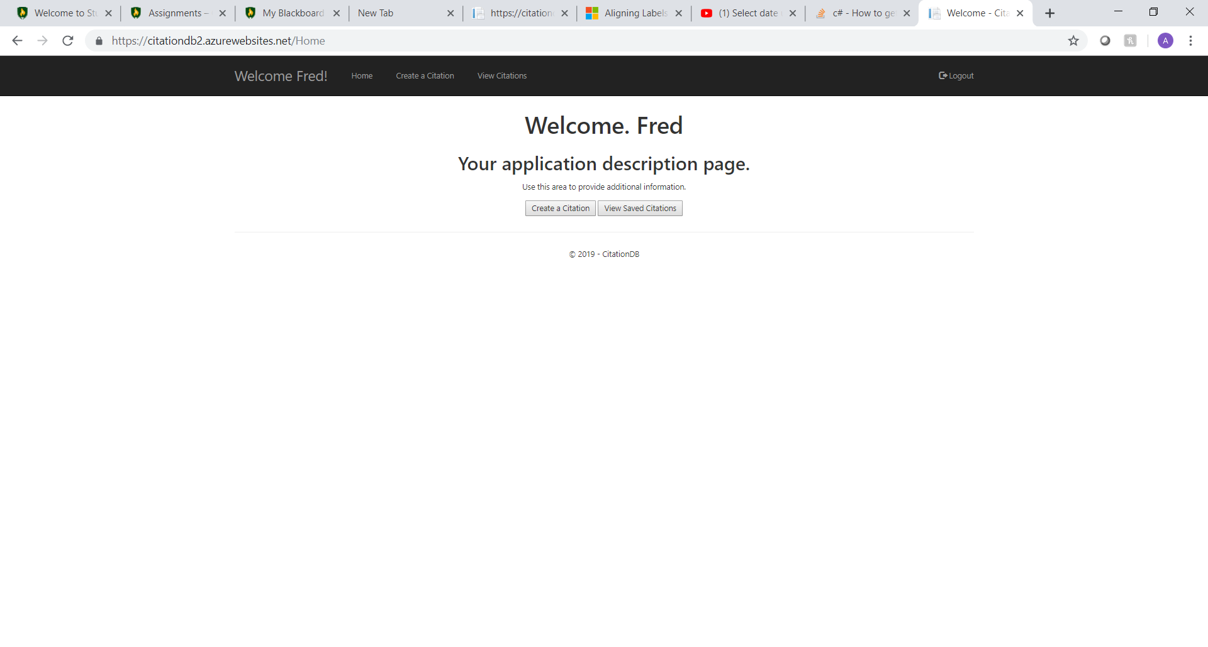Once logged in the user is welcomed to a screen that lets you choose what you want to do. I want to finish this page by making it the main hub where a user could see recent activity. The username is also displayed in the task bar and does change depending on who is logged in.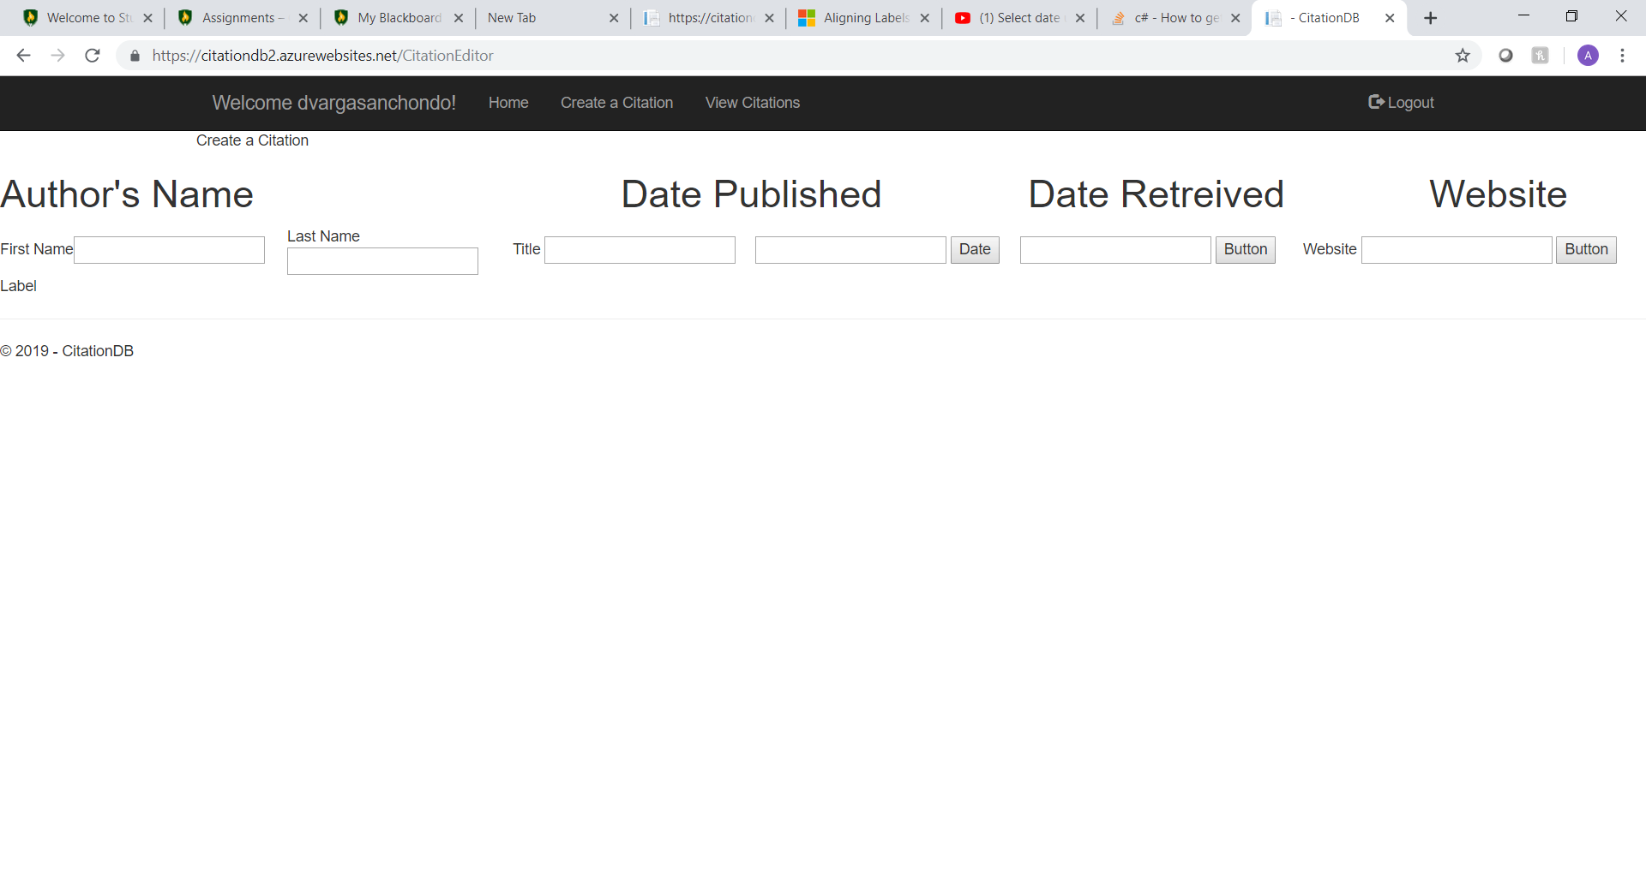When a user is ready to make a citation all they would need to do is insert the information into the fields that are marked. For this project and the limited amount of time I have chosen to focus on APA citations and in a website format.

**Test Code and Screens Function Properly**

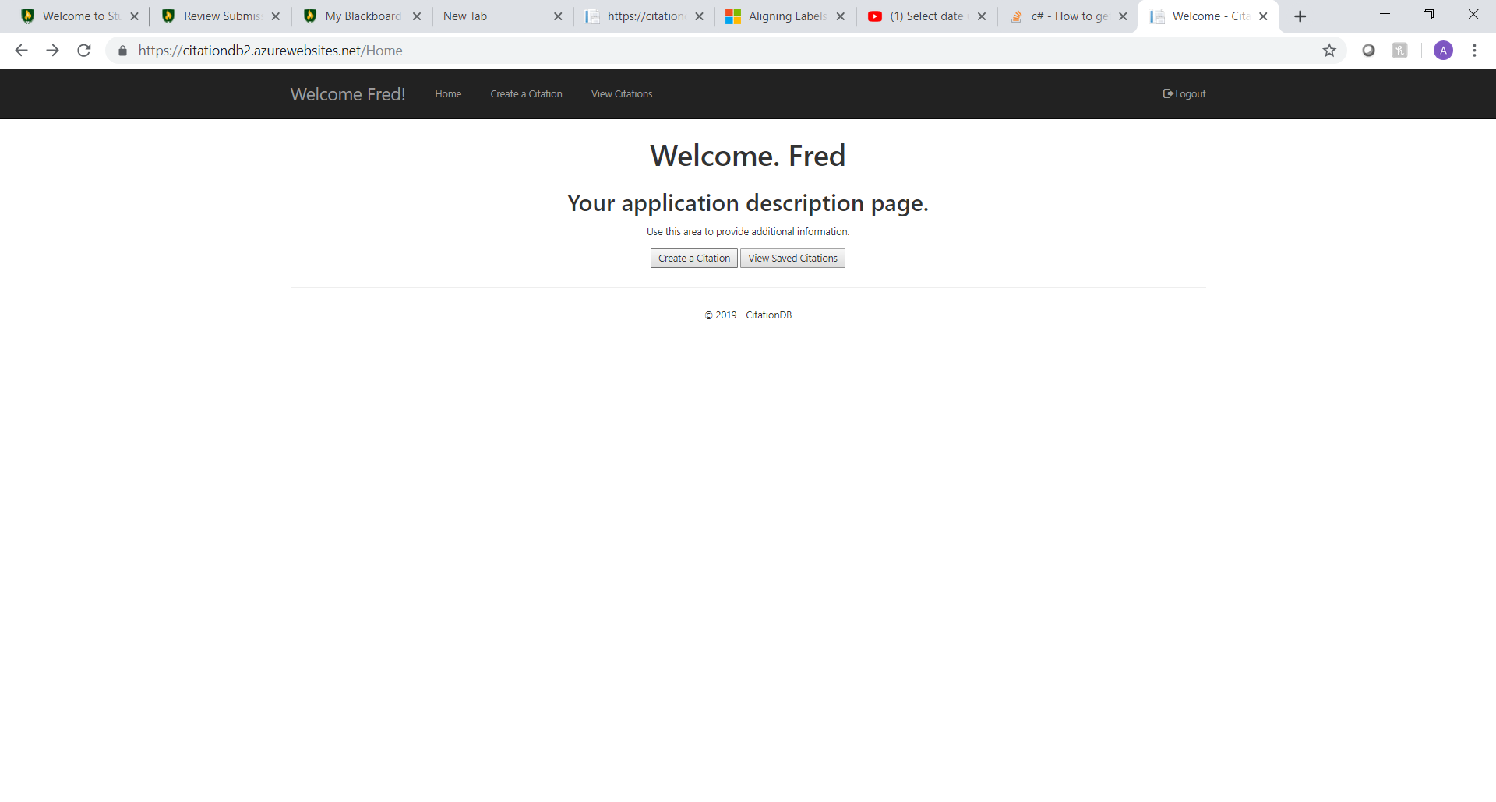

Clicking on the Create a Citation button will navigate to the page where a user could create a citation.

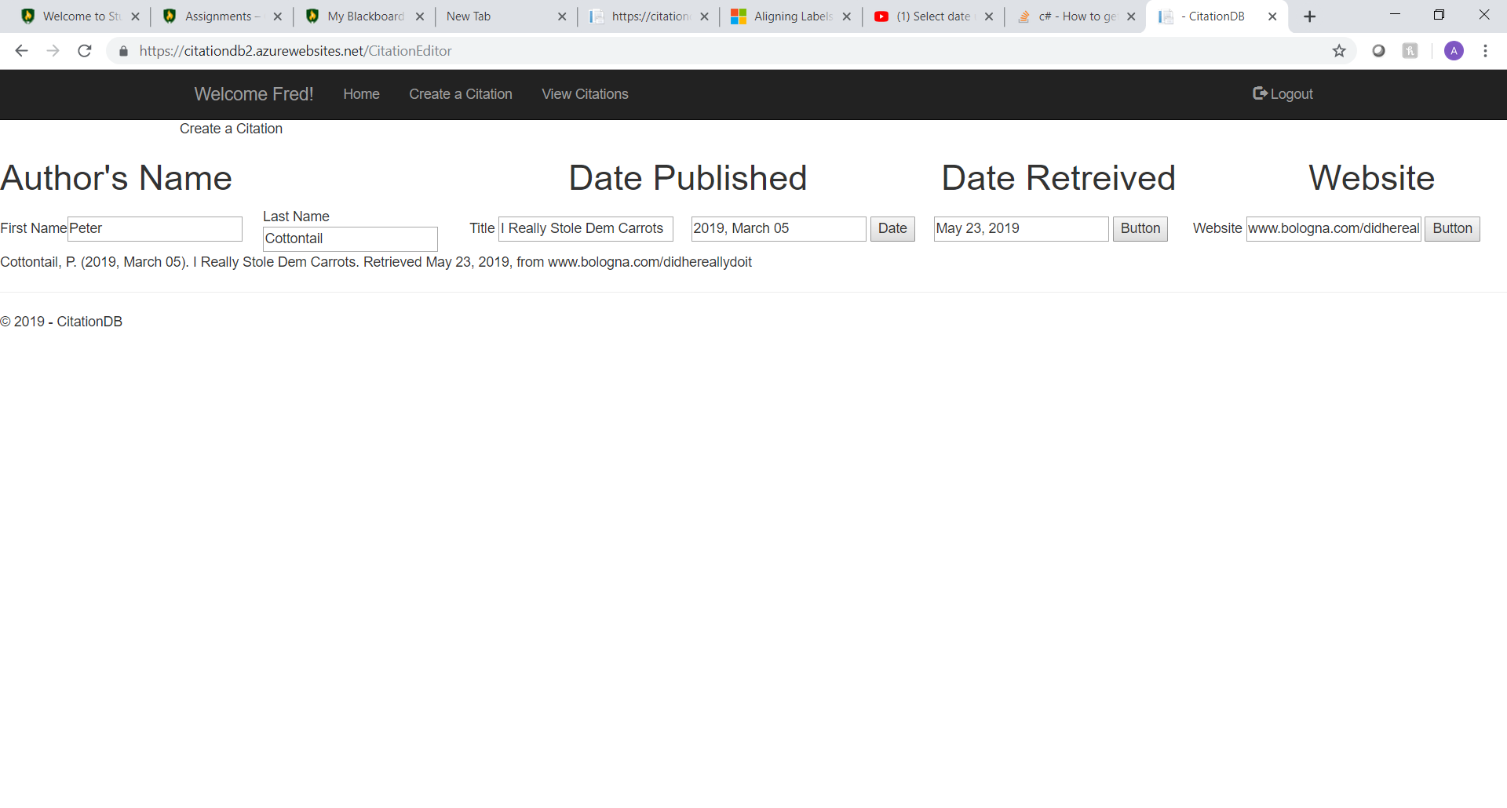The main goal of the application is to have it make citations so here is a sample of the test runs that I have been doing. Before pushing it into the database I want to make sure that the citation that is created is legit and in the correct format so therefore I created a label that will display the citation in the format that it will be saved in. The citation can be located right under the authors name text box.

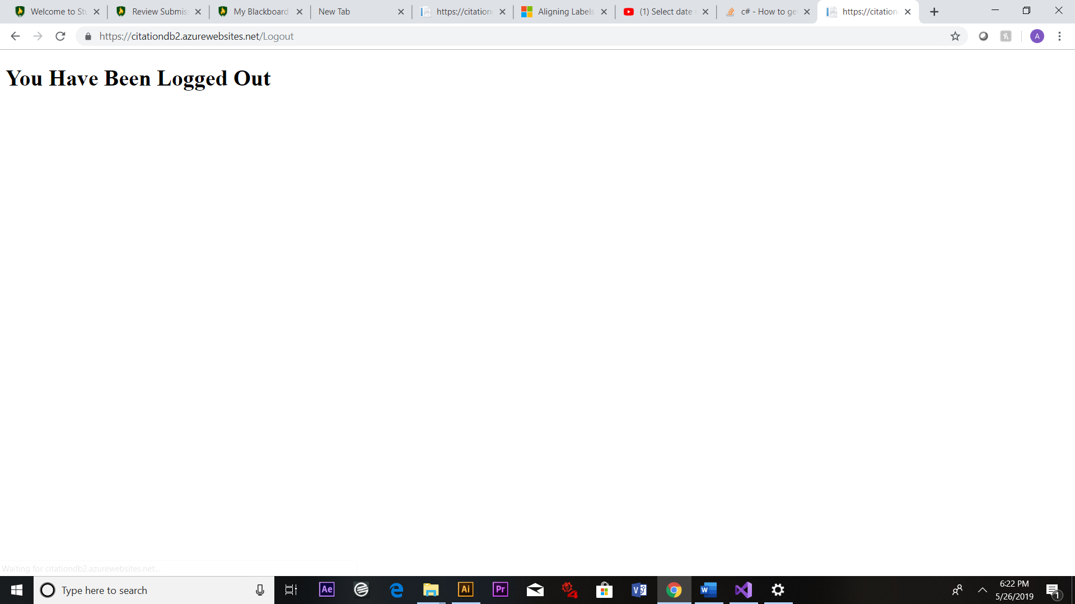

Log out functionality has also been implemented in the top right-hand side of the taskbar. Clicking this would navigate to a logout screen for one second and back to the login screen so another user could log in. The session would also be cleared so that the application could start fresh with the next user that signs in. All the other functions like log in and navigation have been working as demonstrated in last week’s report.

**Create Code for Screen 3 and Log-out Screen**

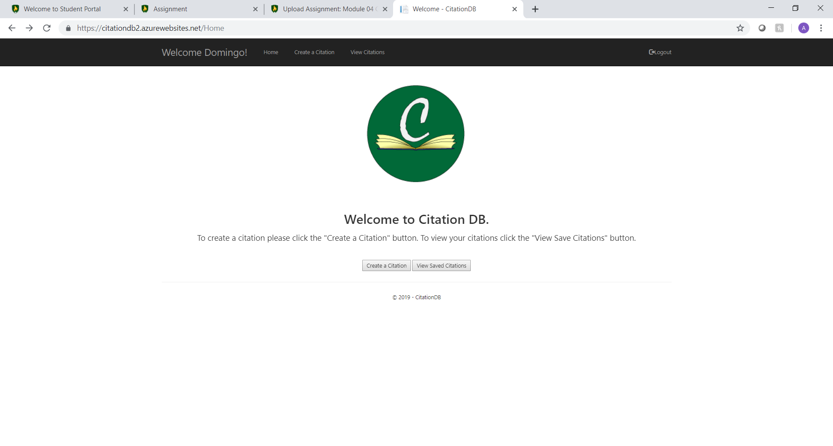

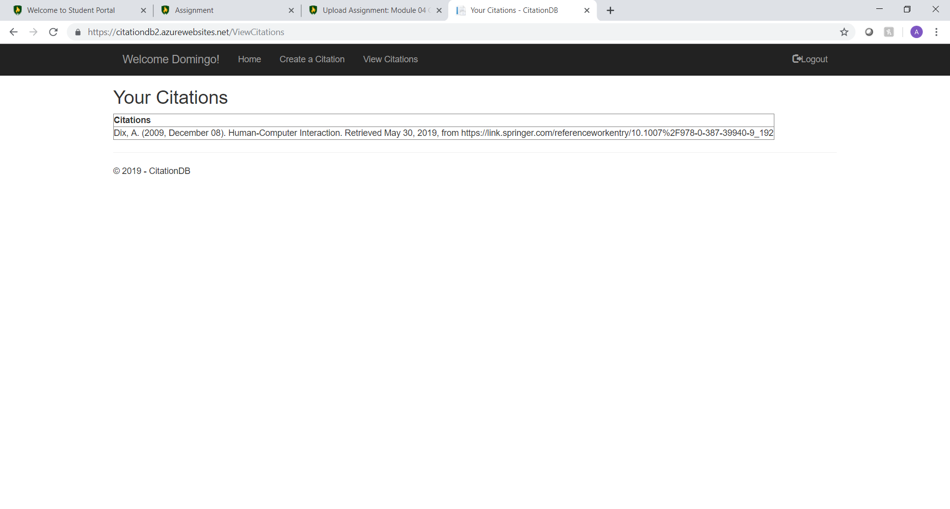

The first example is the primary account that I’ve been using the home screen welcomes the user by their first name in the tool bar which offers navigation and the log out function. With this project my goal was to make the citations made only available to the person who made them so when clicking to view citations only those made by each account are available to see. 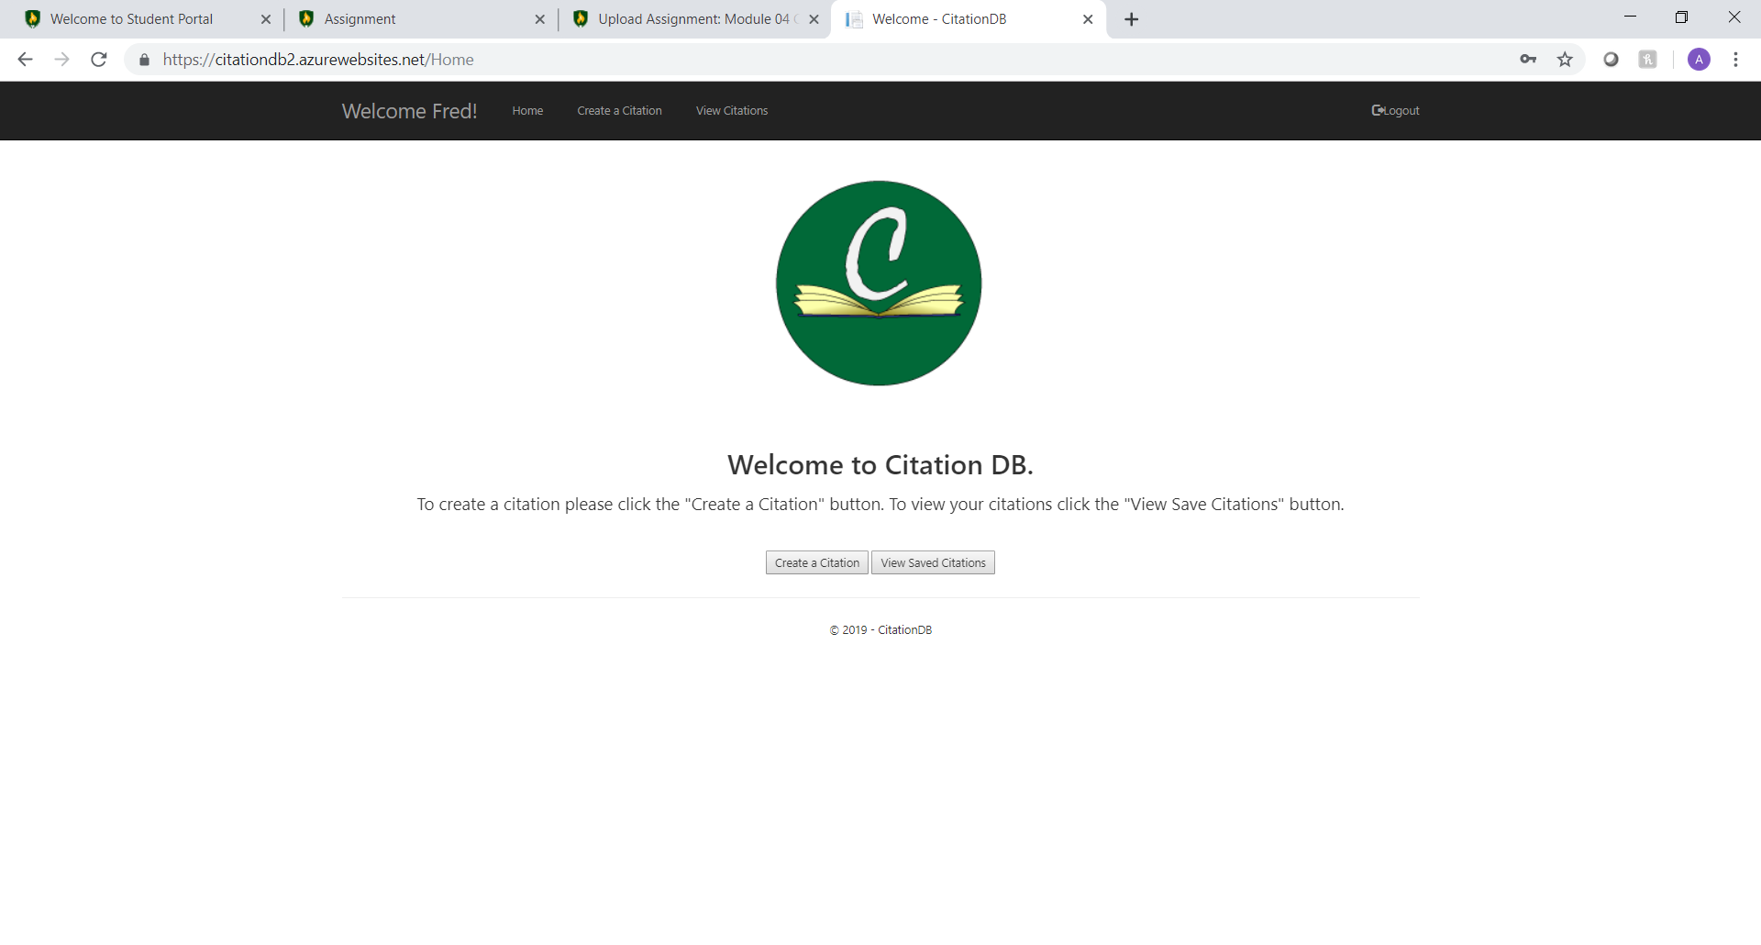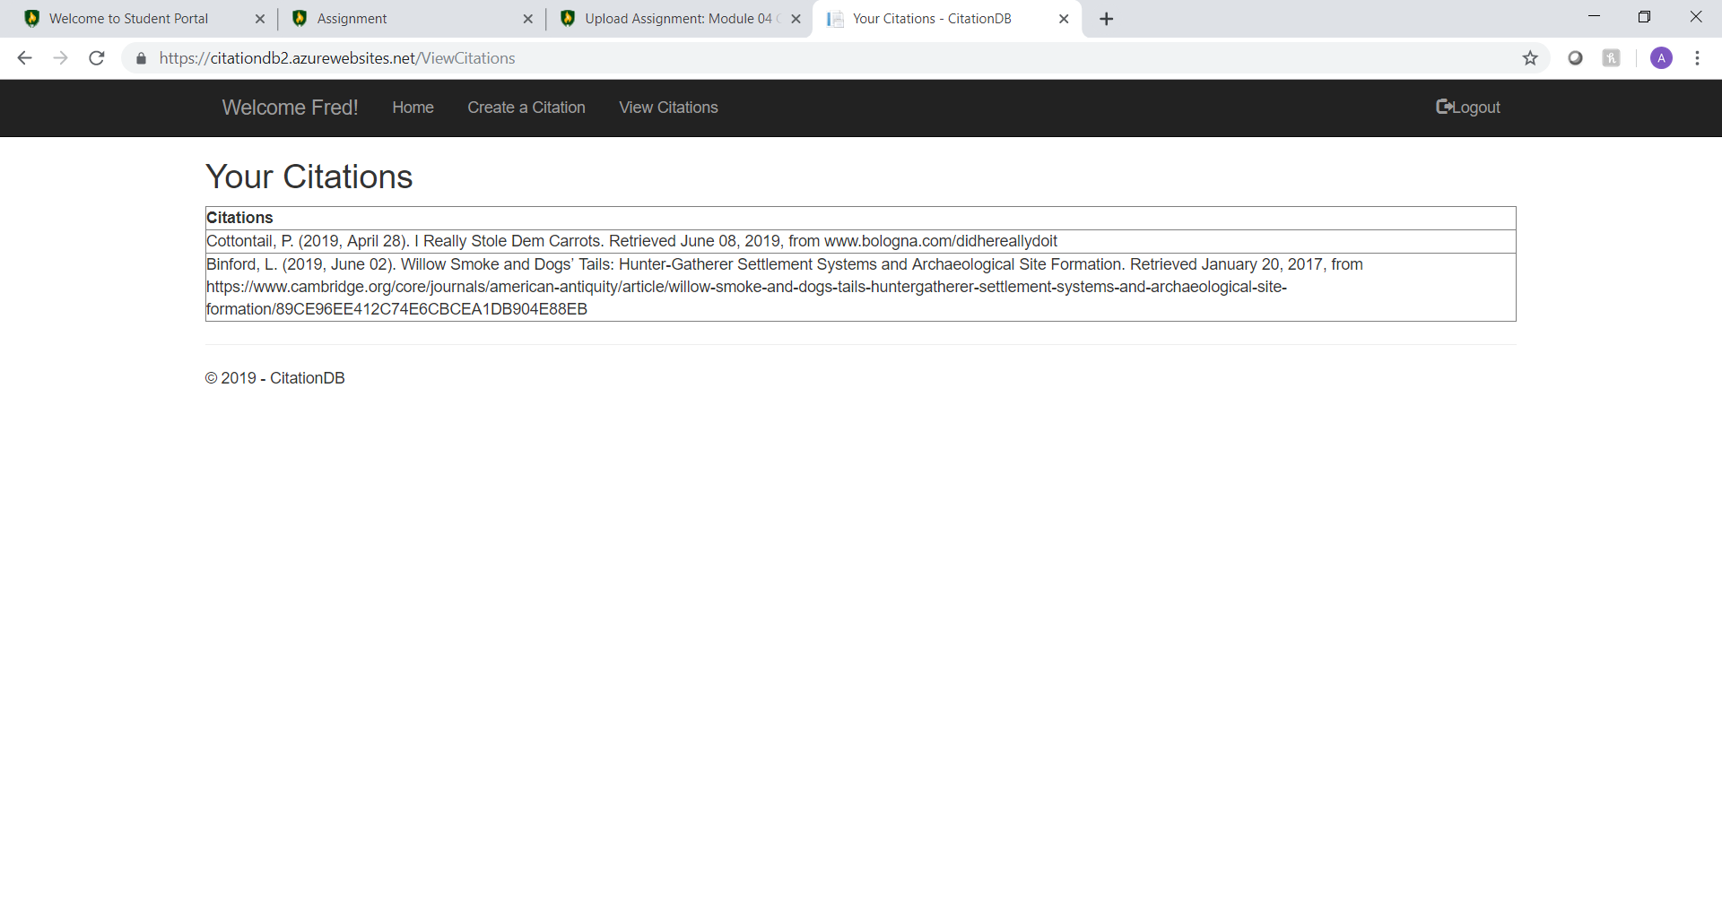This is the same test but with another account I made and I created 2 citations in this account as seen above.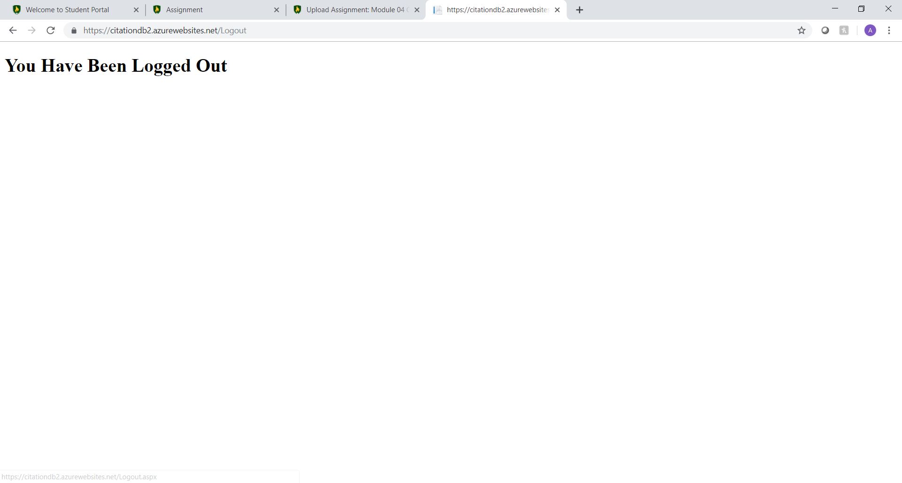The logout screen is still the same but I think I might keep it simple since it redirects pretty quickly as in just enough time to be able to read it and nothing else.

**Test Functionality Week 4**

To start testing we will need an example work that I will be citing in APA format.

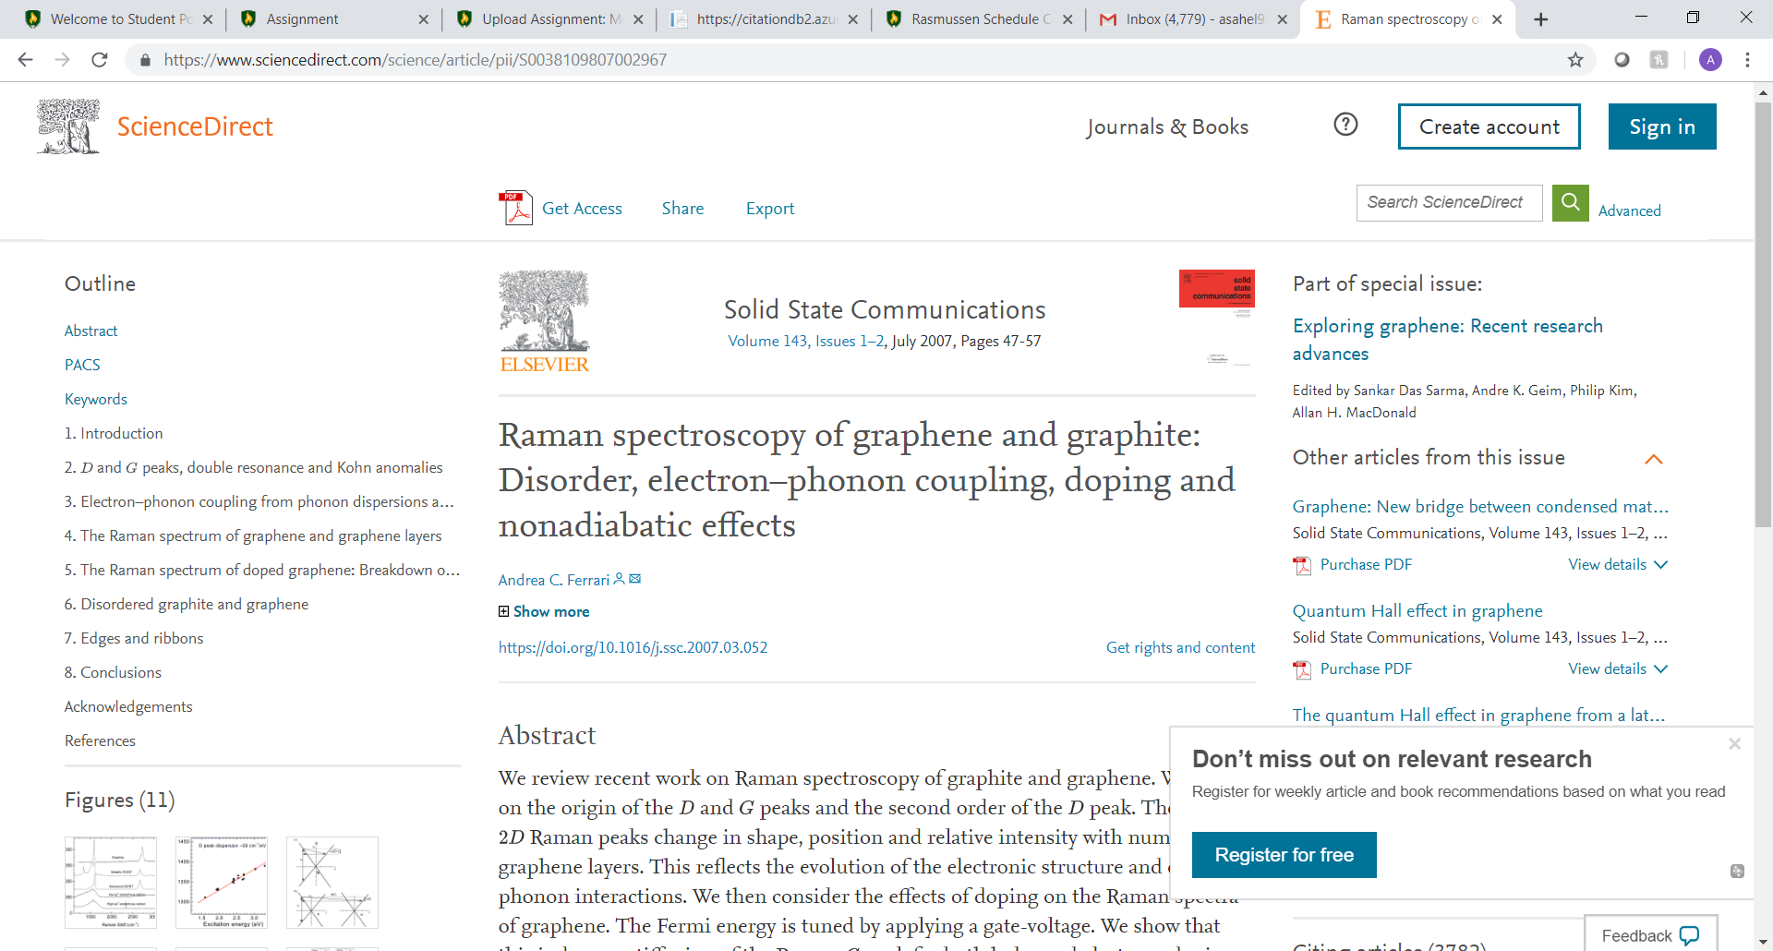

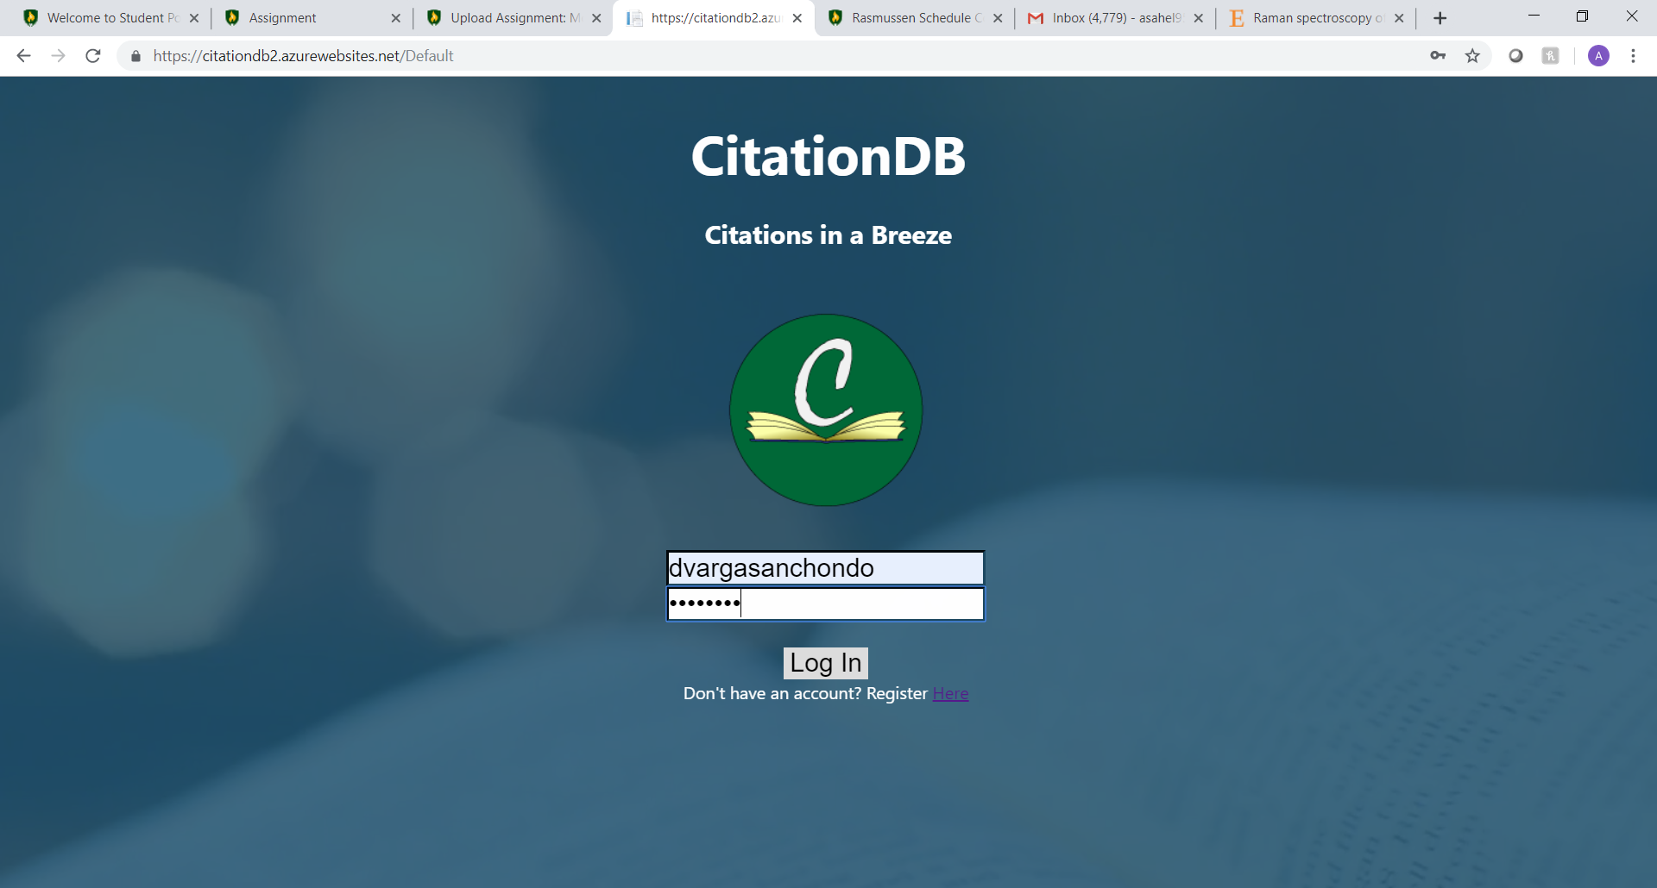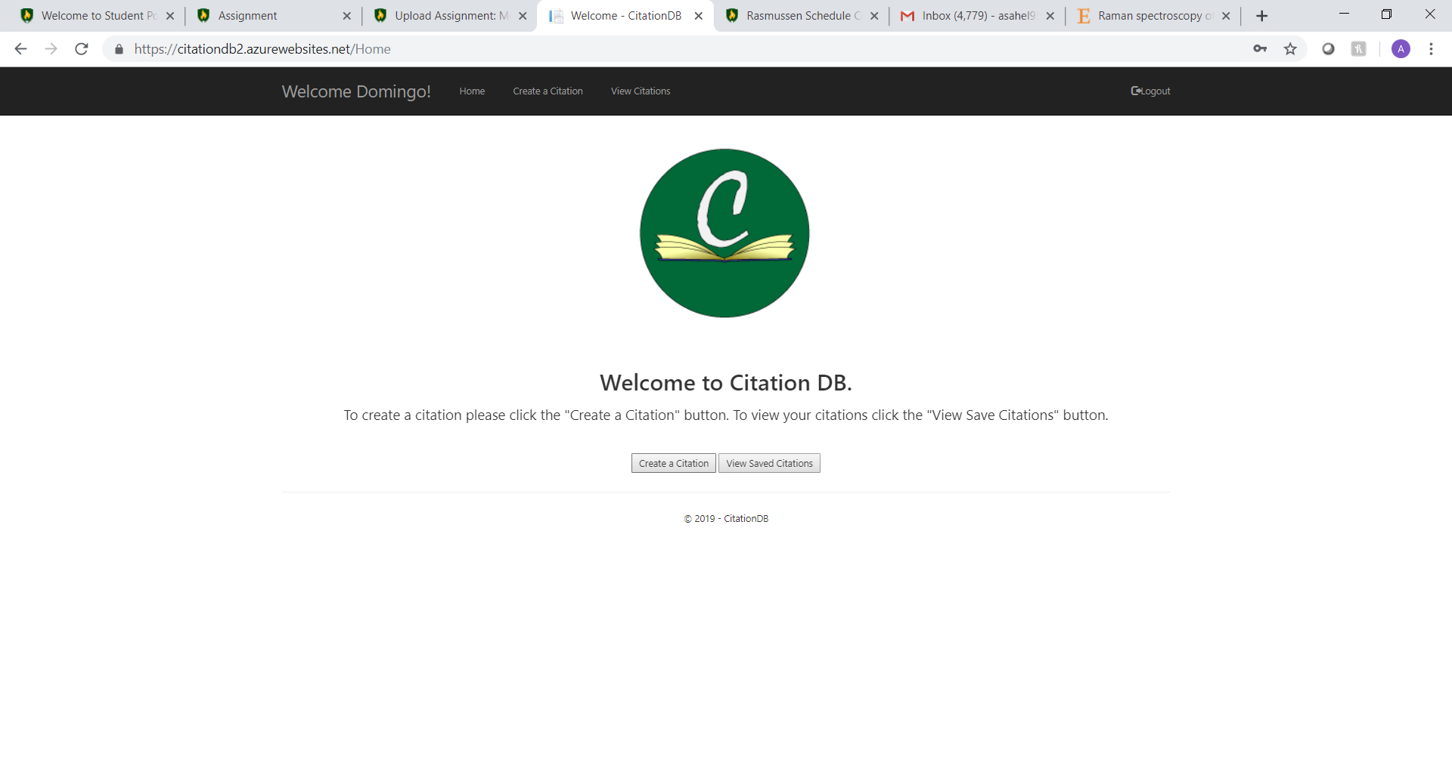

Here we are just inputting the information that is required for the citation.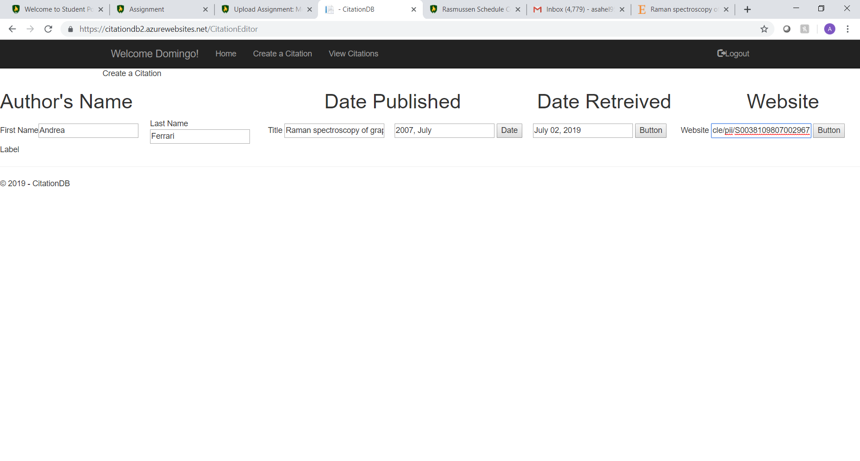

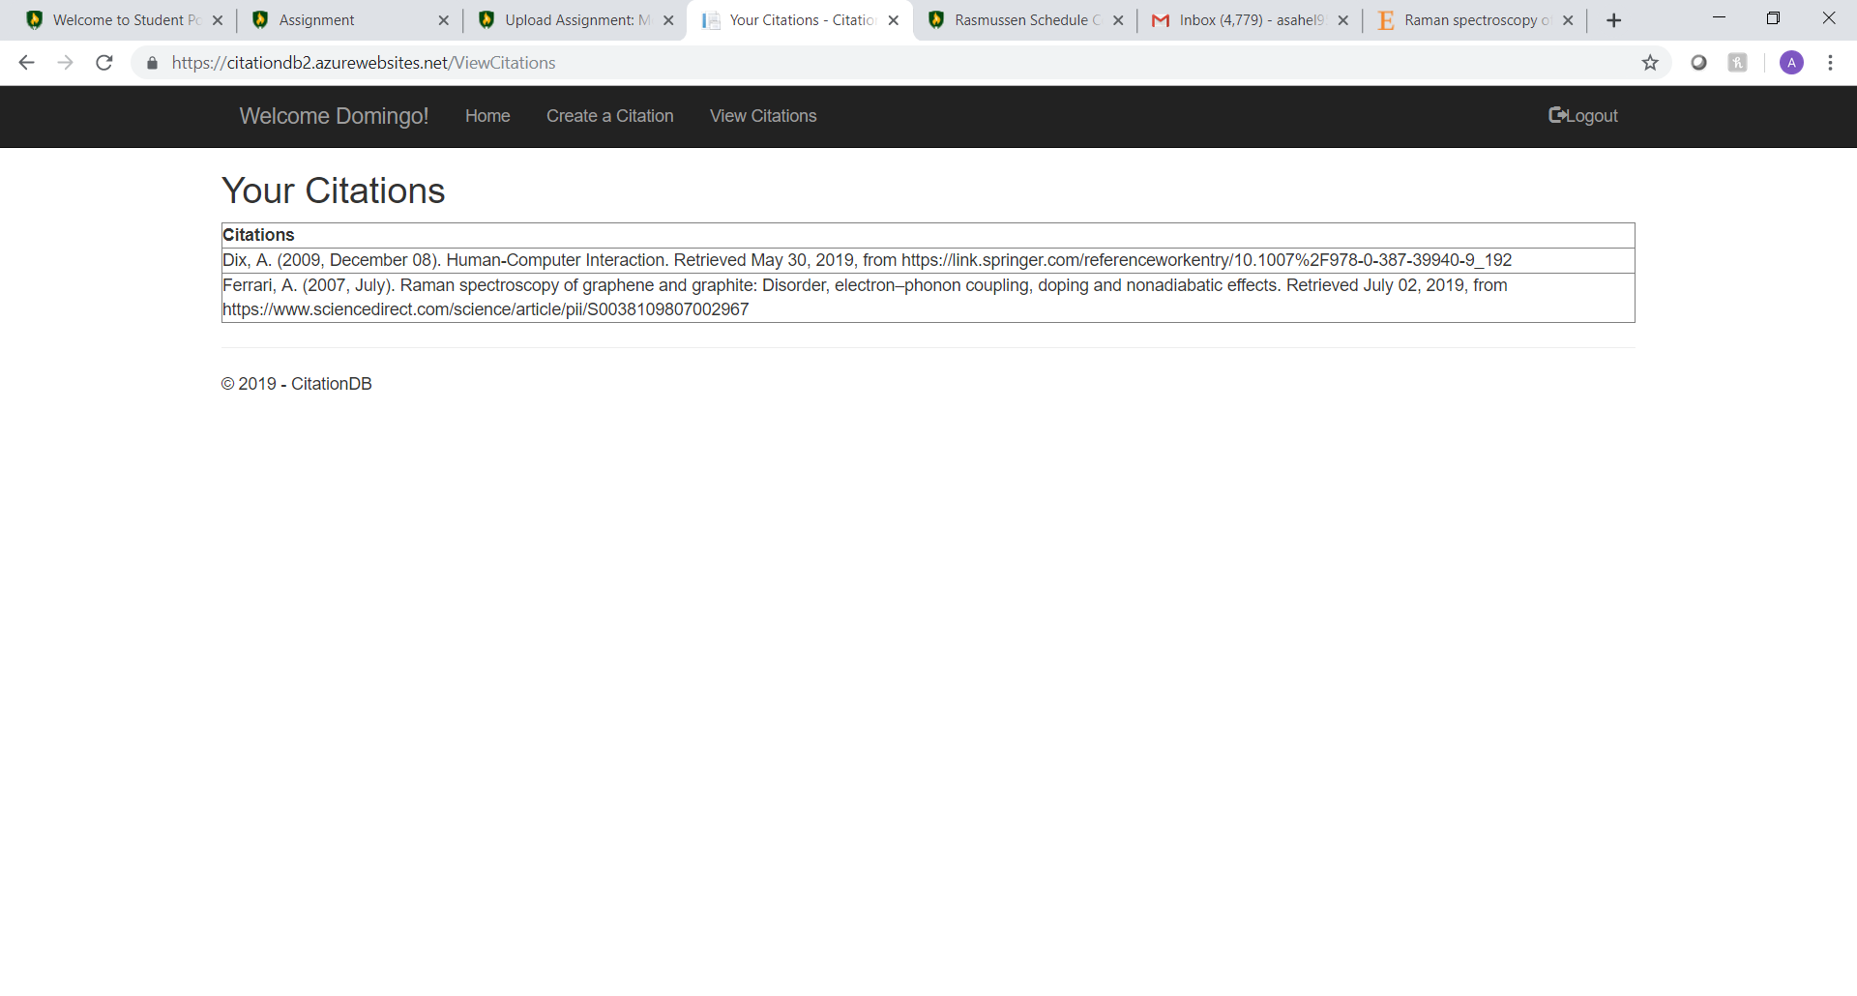Once the information is submitted the citation is displayed in the view citations page. If I logout and login using a different account the citations will be different depending on who is logged in and who made those citations.

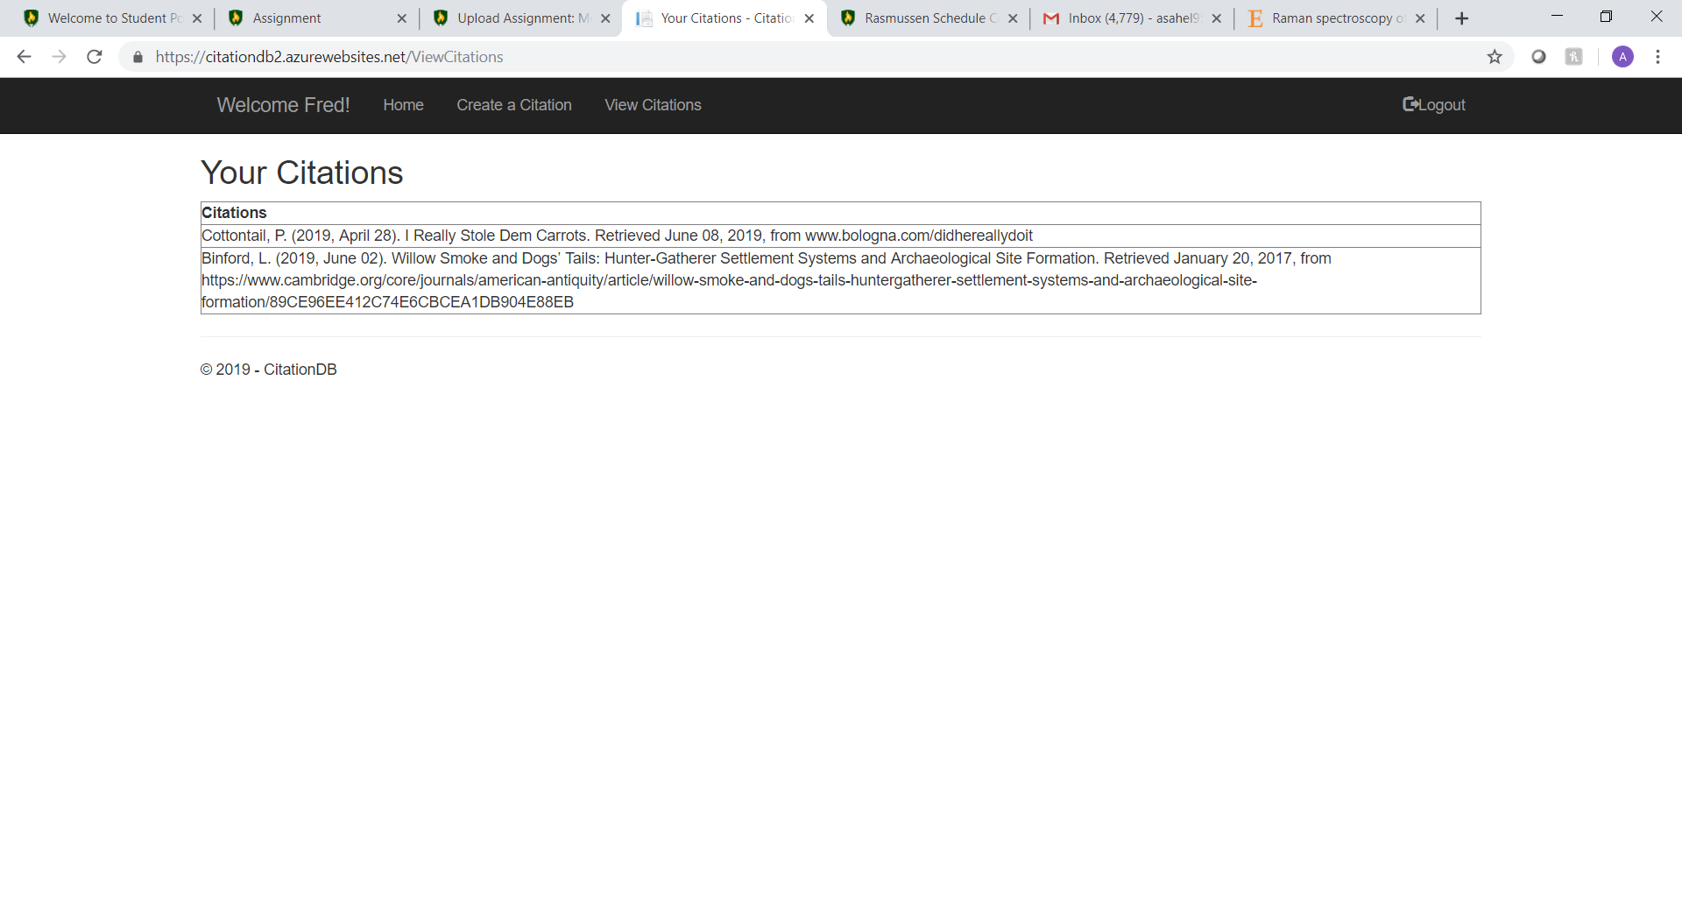

Program Flow Chart

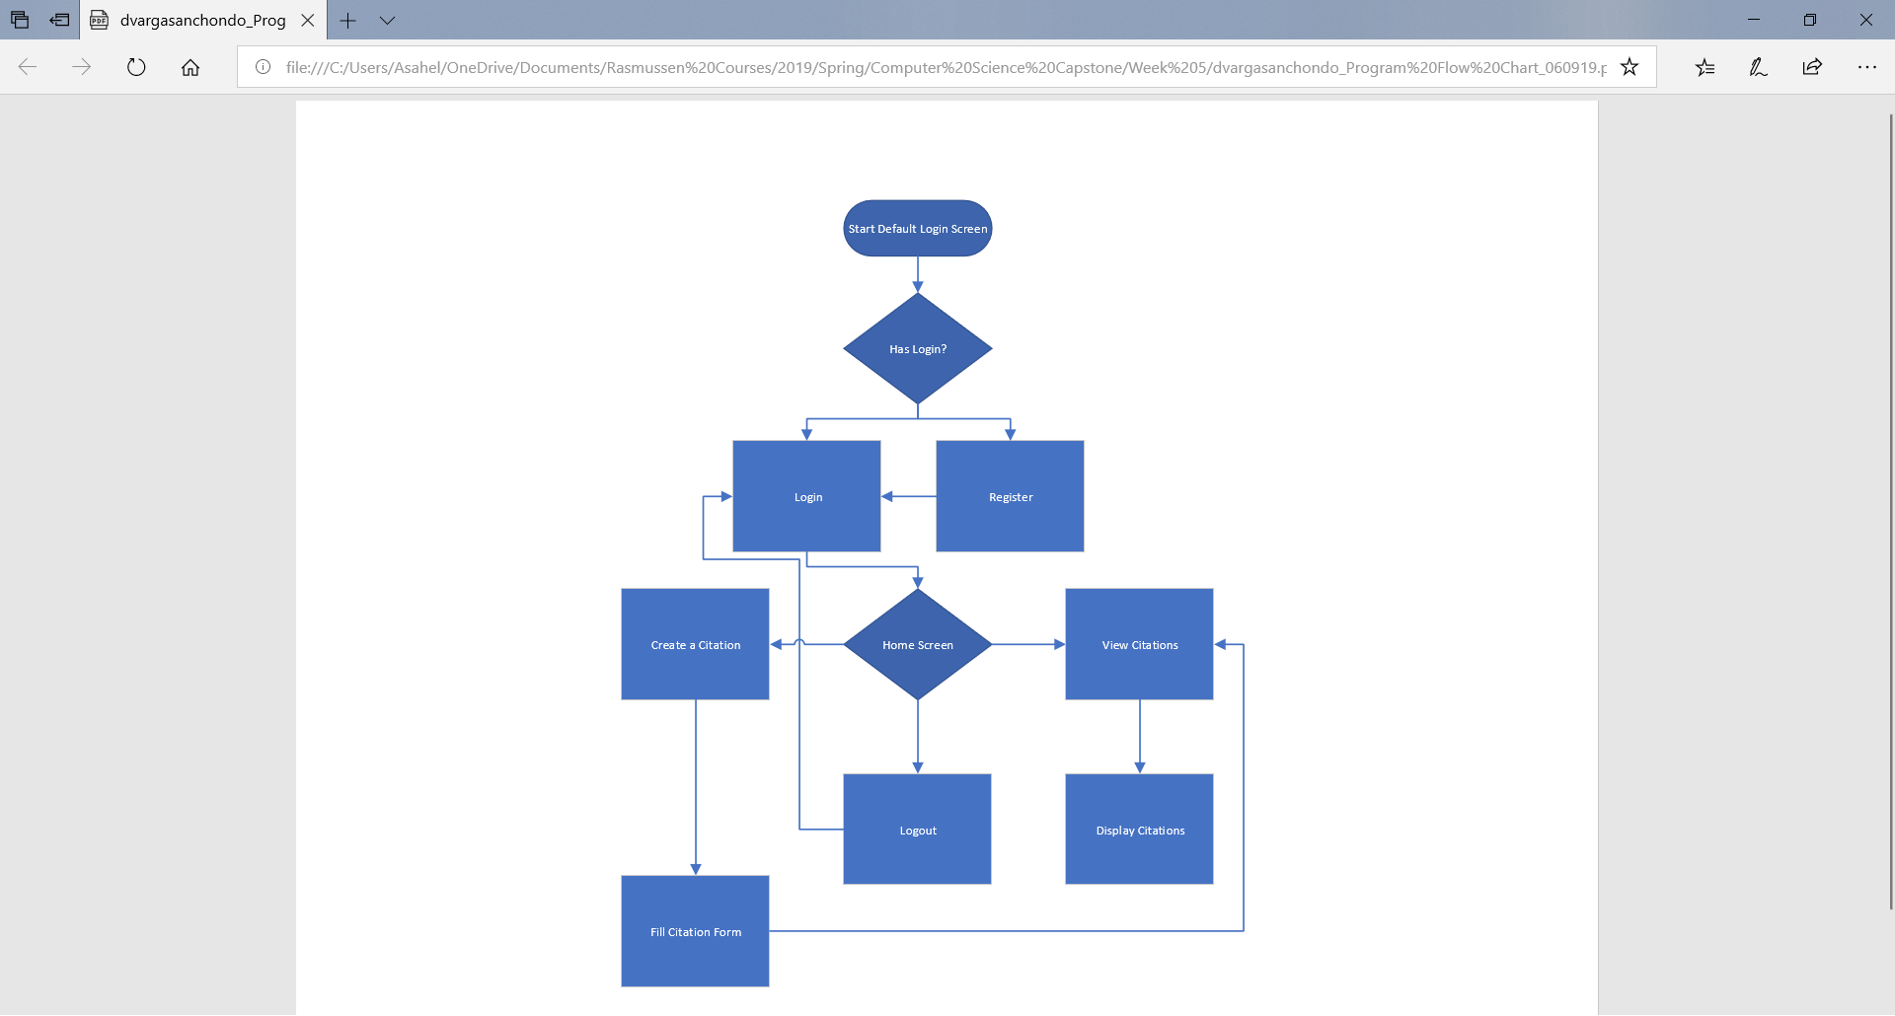

**Completion**

The final project can be accessed at the following site: [https://citationdb2.azurewebsites.net](https://citationdb2.azurewebsites.net/Default)